**API Performance Load test Results**

Load Test 1:

|  |  |
| --- | --- |
| Execution Summary | |
| Users | 100 |
| Rampu up | 100 |
| Duration | 10 min |
| Api Test Case | Get Request without Pacing(Timers) |
| Test Case Uri | GET https://jsonplaceholder.typicode.com/posts/${__Random(1,100,)} |

Observations:

* As the load test conducted without any timers, due to continue hits on the servers we observed some errors are occurring periodically during the test
* In terms of response time average response time is good

Note: Did not increased load as we may encounter too many errors in the absence of timers

Summary Table Metrics

|  |  |  |  |  |  |  |  |  |  |  |
| --- | --- | --- | --- | --- | --- | --- | --- | --- | --- | --- |
| Concurrent Users | # Samples | Average | Min | Max | Std. Dev. | Error % | Throughput | Received KB/sec | Sent KB/sec | Avg. Bytes |
| 100 | 225187 | 244 | 8 | 35940 | 605.85 | 0.11% | 374.9055 | 352.7 | 0 | 963.4 |

Graphic Metrics

**Elapsed Time Vs Average Response Time(Concurrent Users =100)**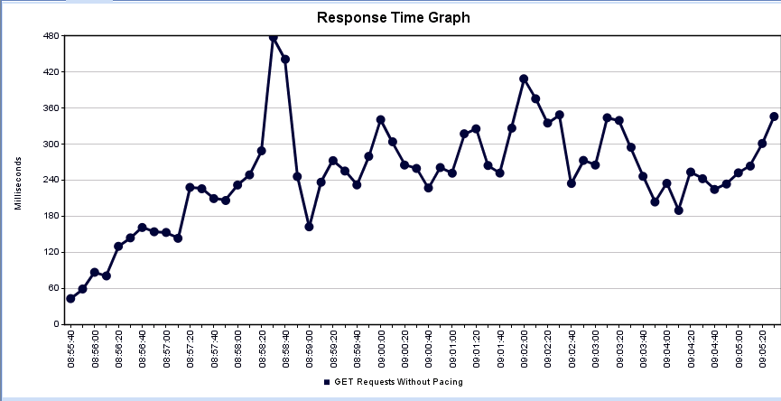

**Load Test 2**

|  |  |
| --- | --- |
| Execution Summary | |
| Users | 100,400,800 |
| Rampu up | 100,100,100 |
| Duration | 10 min,10min,10 min |
| Api Test Case | Get Request with Pacing(Timers) 30 secs |
| Test Case Uri | GET https://jsonplaceholder.typicode.com/posts/${__Random(1,100,)} |

Observations:

* As the load test conducted with 30 sec pacing, no errors observed during the test when compared to load test 1
* In terms of response time average response time is good, as the load increase response time slightly increased and low error % occurred.
* From above results we can conclude that on too high load api could fail at some point

Summary Table Metrics

|  |  |  |  |  |  |  |  |  |  |  |
| --- | --- | --- | --- | --- | --- | --- | --- | --- | --- | --- |
| concurrent Users | # Samples | Average | Min | Max | Std. Dev. | Error % | Throughput | Received KB/sec | Sent KB/sec | Avg. Bytes |
| 100 | 1880 | 56 | 9 | 1238 | 117.1421 | 0 | 3.294073 | 3.089586 | 0 | 960.433 |
| 400 | 9386 | 91 | 8 | 8107 | 276.4751 | 0.01% | 4.324788 | 4.064681 | 0 | 962.4133 |
| 800 | 54431 | 141 | 8 | 35924 | 551.8243 | 0.02% | 11.21864 | 10.54215 | 0 | 962.2529 |

Graphic Metrics

**Elapsed Time Vs Average Response Time(Concurrent Users =100)**

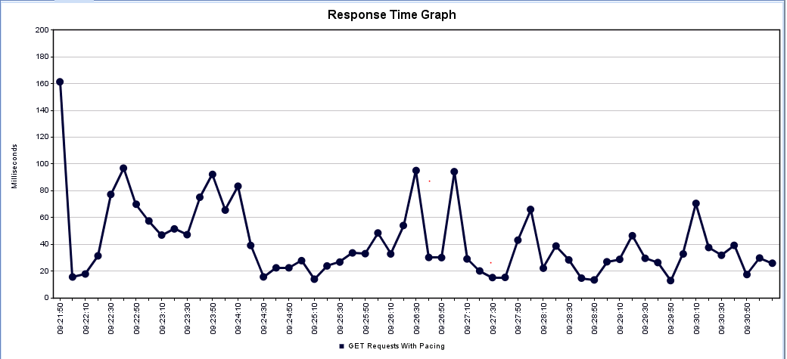

**Elapsed Time Vs Average Response Time(Concurrent Users =400)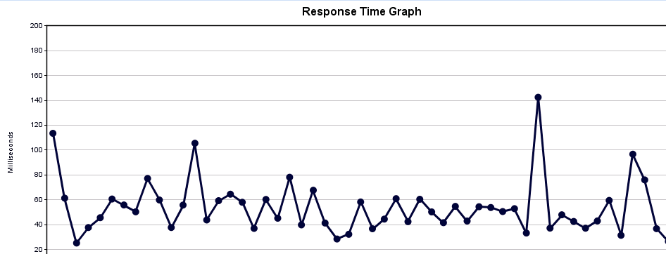 Elapsed Time Vs Average Response Time(Concurrent Users =800)**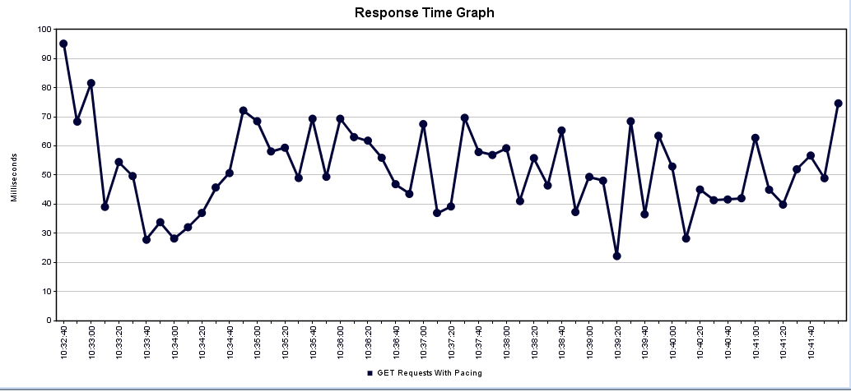

**LoadTest 3**

|  |  |
| --- | --- |
| Execution Summary | |
| Users | 100,400,800 |
| Rampu up | 100,100,100 |
| Duration | 5 min,5min, 5 min |
| Api Test Case | POST Request with Pacing(Timers) 30 secs |
| Test Case Uri | POST <https://api.predic8.de/shop/products/>  Body:{  "name": "Gauva",  "price": ${__RandomString(1,99999,)},  "category_url": "/shop/categories/Fruits",  "vendor_url": "/shop/vendors/672"} |

Observations:

As the load test conducted with 30 sec pacing, no errors observed during the test1

* In terms of response time average response time is good, as the load increase response time slightly increased error
* From above results we can conclude that on too high load api could fail at some point

Summary Table Metrics

|  |  |  |  |  |  |  |  |  |  |  |
| --- | --- | --- | --- | --- | --- | --- | --- | --- | --- | --- |
| concurrent Users | # Samples | Average | Min | Max | Std. Dev. | Error % | Throughput | Received KB/sec | Sent KB/sec | Avg. Bytes |
| 100 | 875 | 434 | 252 | 2162 | 407.7317 | 0 | 3.214749 | 2.118089 | 0 | 674.6789 |
| 400 | 4366 | 653 | 250 | 6804 | 1163.336 | 0.00% | 6.22488 | 4.115144 | 0 | 676.9459 |
| 800 | 11340 | 788 | 250 | 11157 | 1664.863 | 0.00% | 10.07957 | 6.673615 | 0 | 677.9834 |

Graphic Metrics

**Elapsed Time Vs Average Response Time(Concurrent Users =100)**

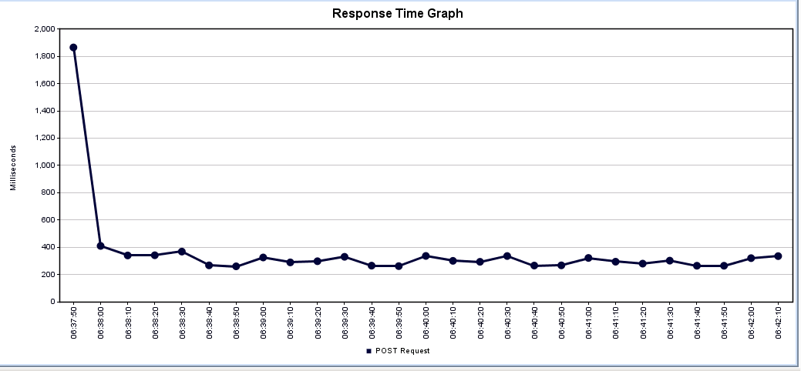

**Elapsed Time Vs Average Response Time(Concurrent Users =400)**

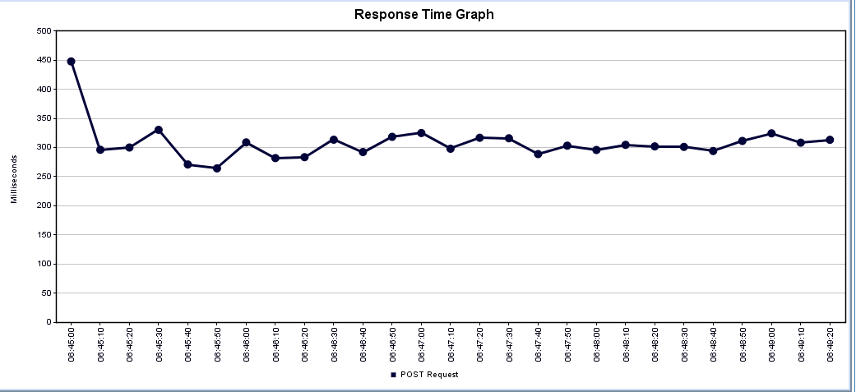

**Elapsed Time Vs Average Response Time(Concurrent Users =800)**

